Course Project - [Electricity, Magnetism, and Light Compare/Contrast Paper](https://learning.rasmussen.edu/webapps/assignment/uploadAssignment?content_id=_7098804_1&course_id=_77026_1&group_id=&mode=view)

Shaun Pritchard

Rasmussen College

PHY4060

Arunava Roy

November 30, 2020

**Course Project -** [**Electricity, Magnetism, and Light Compare/Contrast Paper**](https://learning.rasmussen.edu/webapps/assignment/uploadAssignment?content_id=_7098804_1&course_id=_77026_1&group_id=&mode=view)

Based on the following scenario we can see that electricity and magnetism, in numerous effects based on physics principles and theories can be applied. Mandy took a trip to Rome I assumed it was in an aircraft because it said: "once it landed inside the terminal". Aircraft have some of the most advanced electronics systems in the world such as avionics which are the electronic systems used on aircraft, satellites, and spacecraft. Avionic systems include communications, navigation, display, and management devices of multiple systems fitted to aircraft to perform individual functions. One of the most unique functions and devices used on an airplane that we can directly attribute Maxwell for is modern radar systems *(UNIVERSITY PHYSICS VOLUME, 2020).*

Radar Systems send out electromagnetic waves similar to mobile phones to determine the range, angle, and velocity of objects. The signals are sent out as short pulses which are reflected by objects in their path. which then reflect the radar producing images of obstructions. in the field path. Such as other airplanes, mountains, towers, etc. The electromagnetic waves that a radar emits microwaves from magnetron transmitters which are essentially microwave oscillators. Which peak power in the order of 100kw which is ${10}^{-2 }$ on the EM (electromagnetic) spectrum. Maxwell’s equations used with vector calculus relating to electric magnetic fields underline all electrical, optical, and radio technologies we use today *(Borden, 2009).*

Maxwell's equations are used to define the following principles in radar technology. Using many mathematical theorems and laws like Gauss’s law, Faraday’s law, Ampere’s law, Stokes law, Fourier Transforms, divergence theorem, and many others.

**Maxwell’s equations and principles used in radar technology:**

* Wave Propagation Equation - A second-order linear partial differential equation for the description of waves.
* Plane‐Wave Propagation - calculation of axis fields and reduction of distant space on a propagating wave with a planar
* wave‐front or plane-wave.
* Plane‐Wave Reflection - linear wave propagation based on Reflection and transmission of radar waves.
* Dielectrics Boundary - Equation used to determine boundary conditions
* Point Sources and Reflections - Law of angular reflection
* Complicated Scattering - calculation of deviating particles or radiation in an electric field.
* Born Approximation - Approximating the wave particles that are not scattered
* Antennas - Used to calculate, transmit and receive propagating E and M fields from signal voltages/current.

Almost every system used today is modeled or has roots in using the principles discovered by Maxwell. When Mandy got into the terminal, she turned her cell phone on because it is required, she turn it off on the airplane. This is because mobile devices and other electronics emit high-frequency radio waves that pose a risk to the avionics technology and can interfere with the aviation and communication devices on the plane or with the pilots *(Moran, 2007).*

Mandy found a charging station with a universal USB adaptor port because her phone was dead. The USB was said to be a universal port providing 5 volts in any country. Indicating a red LED next to her phone's screen to inform her the phone was successfully charging. This is known as fast charging and it increases the current (I) set to the mobile device battery to fill the capacity quicker. typically, this fast current would increase the volume in amperes of current using 5 volts increase a normal charge of 2.5 watts(W); doubling the capacity of flow to the battery. This USB port seemed to have very high amperage, meaning it charged her phone quickly. This would indicate but we know today as fast charging *(Triggs, 2019).*

We also have to take into consideration the power systems difference in each country. Electricity in Italy, as in the rest of Europe, comes out of the wall socket at 220 volts alternating at 50 cycles per second. In the US, electricity comes out of the wall socket at 110 volts, alternating at 60 cycles per second. So, we get lower volts at a faster rate while they consume more electricity at 10% deficiency compared to that of the U.S.A *(Martha Bakerjian, 2020).*

There is also mention that Mandy said assuming a disregard for using a cord in Italy because she stated the electricity in Italy was generated by burning fossil fuels. Although Fossil fuels are used globally, a spectrum of other energy-producing methods is also used. She would be correct in assuming this because according to the data from the Italian EIA Energy Information Administration  *(EIA, 2020)*. They are ranked 48 on the international scale of energy consumption using 112.08 million Btu per person. Italy is the second-largest natural gas importer in Europe after Germany, and the third-largest consumer of natural gas after Germany and the United Kingdom *(Our World In Data, 2020).*

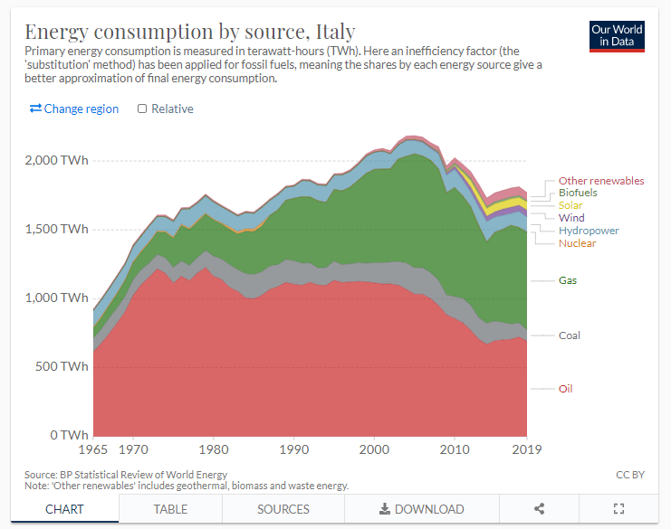

We can see through the data that her concern is valid. Regardless, she decided to use a portable solar charger. Solar chargers work using photoelectric principles. These Chargers use a photocell which is essentially a resistor that changes resistance depending on the amount of light got it consumes. Operates on semiconductor photoconductivity. Which the natural light wave energy of photons hitting the semiconductor frees electrons to flow, decreasing the resistance therefore charging the battery cell. Solar battery chargers do not directly charge the lithium-ion battery in a mobile device they charge an internal rechargeable battery that is redistributed to the mobile device *(Howstuffworks.com, 2020).*

Portable solar chargers are may seem more efficient and sustainable than grid-based socket electricity which is distributed and consumed from a typical wall outlet, but portable solar chargers only work if it can consume electrons from the suns visible light or trace amounts of ultraviolet light. If it is not available or the sun is not out, she will not be able to rely on that technology to charge her phone.

We can see all of these systems, devices, and models are based on the contributions of Maxwell's equations which have an effective implementation on all modern electronic devices. In regard to my own experience as an aspiring computer scientist. Maxwell’s unifying equations allowed scientists to discover radio waves, which led to advances in the study and understanding of light and technology. Technology I currently use every such as my desktop computer and the internet. Could not exist only based on the electronic circuit components but modern inventions such as our Wi-Fi Routers *(Dingman, 2020)*.

The electromagnetic radiation emanating from the antenna in a wireless router is caused by a small current oscillating at 2.4GHz (2.4 billion times per second). Maxwell’s equations dictate how the resulting electromagnetic waves flow giving us the confines of advanced communications technology we all use today *(Dingman, 2020).*

# References

Borden, M. C. (2009). *Fundamentals of Radar Imaging.* USA: National Science Foundation.

Dingman, J. (2020, 18 June). *Why We Have Gadgets: Electromagnetism*. Retrieved from https://sciworthy.com/: https://sciworthy.com/why-we-have-gadgets-electromagnetism/

EIA. (2020). *Italy*. Retrieved from https://www.eia.gov/international/overview/country/ITA: https://www.eia.gov/international/overview/country/ITA

Howstuffworks.com. (2020). *How Solar Battery Chargers Work*. Retrieved from howstuffworks.com: https://electronics.howstuffworks.com/gadgets/travel/solar-battery-chargers.htm

Martha Bakerjian. (2020, 01 04). *Electricity in Italy - Plugs, Adapters and Converters*. Retrieved from tripsavvy.com: https://www.tripsavvy.com/electricity-in-italy-1548048

Moran, B. (2007). *Mathematics of Radar.* Pennsylvania : Pennsylvania State University.

Our World In Data. (2020). *Energy consumption by source, Italy*. Retrieved from https://ourworldindata.org: https://ourworldindata.org/energy/country/italy

Triggs, R. (2019, June 30). *How fast charging really works*. Retrieved from www.androidauthority.com: https://www.androidauthority.com/fast-charging-explained-889780

UNIVERSITY PHYSICS VOLUME. (2020). *Maxwell’s Equations and Electromagnetic Waves.* Los Angels: Open Text BC.